Protected Species Mitigation and Monitoring Report

Marine Geophysical (Seismic) Survey

North Pacific Ocean

Queen Charlotte Fault

18 July 2021 – 23 August 2021

R/V Marcus G. Langseth

Prepared for:

Lamont-Doherty Earth Observatory of Columbia University
61 Route 9W, P.O. Box 1000, Palisades, NY 10964-8000

for submission to:

National Marine Fisheries Service, Office of Protected Resources

1315 East-West Hwy, Silver Spring, MD 20910-3282

Project No. | 213883 | RPS
Cruise ID No. | MGL2105 | 20405 Tomball Parkway Building 2, Suite 200
Authors | Cassandra Frey | Houston, Texas 77070, USA
 |  | Tel: (281) 448-6188
Reviewer(s) | Katie Dekis | Fax: (281) 448-6189
Submittal Date | 17 December 2021 | E-mail: katie.dekis@rpsgroup.com
 |  | Website: www.rpsgroup.com

TABLE OF CONTENTS
Acronyms and Abbreviations 1
1. Executive SUMMARY 2
2. Introduction 4
2.1. Project Overview and location 4
2.1.1. Energy Source and Receiving Systems 5
3. Mitigation and monitoring Methods 7
3.1. Mitigation Methodology 7
3.2. Visual Monitoring Survey Methodology 10
3.3. passive Acoustic Monitoring Survey Methodology 12
3.3.1. Passive Acoustic Monitoring Parameters 13
3.3.2. Hydrophone Deployment 15
4. Monitoring Effort Summary 16
4.1. Survey Operations Summary 16
4.1.1. General survey parameters 16
4.1.2. MBES, SBP and ADCP operations 17
4.1.3. Acoustic source operations 17
4.1.4. Interactions with Other Vessels 17
4.2. Visual Monitoring Survey Summary 18
4.3. Acoustic Monitoring Survey Summary 19
4.4. Simultaneous Visual and Acoustic Monitoring Summary 19
4.5. Environmental conditions 20
5. Monitoring and Detection Results 22
5.1. Visual Detections 22
5.1.1. Other Wildlife 26
5.2. Acoustic detections 26
6. mitigation action summary 27
6.1. Protected Species known to have been exposed to 160 decibels or Greater of received sound levels 28
6.2. implementation and effectiveness of the biological opinion’s its and iha 29
7. Literature Cited 31

LIST OF FIGURES
Figure 1. Location and survey points of the marine geophysical survey. 5
Figure 2. Protected Species Observer stern view of observation tower with mounted big-eye binoculars. 11
Figure 3: Simplified pathway of data through the PAM system on board the Langseth. 13
Figure 4. Location of the PAM cable in relation to the seismic gear during the survey. 15
Figure 5: All protected species detections during the survey. 23
Figure 6: All protected species observed during the survey by species group. 24

LIST OF TABLES
Table 1: Specific detections of protected species and their required mitigation actions. 8
Table 2: Separation distances, and buffer and exclusion zone sizes for each species/species group expected to occur in the survey area. 9
Table 3: Predicted 160/175/195 Decibel Zones* Implemented during the survey. 10
Table 4: Predicted Level A Harassment Zones* for each Marine Mammal Hearing Group Implemented during the survey. 10
Table 5: Survey parameters 16
Table 6: Suspension of source operations during the survey. 16
Table 7. Total acoustic source operations during the seismic survey. 17
Table 8: Initiation and termination of visual monitoring during the survey. 18
Table 9. Total visual monitoring effort during the survey. 18
Table 10: Total visual monitoring effort from observation locations during the survey. 18
Table 11: Initiation and termination of acoustic monitoring watches during survey. 19
Table 12. Total Passive Acoustic Monitoring (PAM) effort during the survey. 19
Table 13: Simultaneous visual and acoustic monitoring effort during the survey. 19
Table 14. Visibility during the survey. 20
Table 15. Precipitation during the survey. 20
Table 16. Beaufort Sea State during the survey. 20
Table 17. Wind speed during the survey. 20
Table 18. Swell Height during the survey. 20
Table 19. Glare during the survey. 21
Table 20. Number of visual detection records collected for each protected species during the survey. 22
Table 21. Average closest approach of protected species to the acoustic source at during the survey. 25
Table 22. Number and duration of mitigation actions implemented during the survey. 27
Table 23. Number of authorized and potential Level A and B Harassment Takes during the survey. 28

APPENDICES:
Appendix | Description
Appendix A | NMFS & USFW Incidental Harassment Authorization
Appendix B | Biological Opinion
Appendix C | Passive Acoustic Monitoring System Specifications
Appendix D | PAM Hydrophone Deployment
Appendix E | Photographs of Protected Species Visually Detected
Appendix F | Birds and Other Wildlife Observed

Acronyms and Abbreviations
ADCP – Acoustic doppler current profiler
BiOp – Biological Opinion (US)
BOEM – Bureau of Ocean Energy Management
BSS – Beaufort Sea States
BZ – Buffer Zones
DAQ – Data acquisition
dB - decibels
DFO – Department of Fisheries and Ocean (Canada)
DSLR – Digital Single Lens Reflex
EA – Environmental Assessment (US)
EPU – Electronic Processing Unit
ESA – Endangered Species Act (US)
EEZ – Economic Exclusion Zone
EZ – Exclusion Zone
FONSI – Finding of No Significant Impact (US)
FWS – Fish and Wildlife Service (US)
GPS – Global Positioning System
HF – High Frequency
HZ - Hertz
IHA – Incidental Harassment Authorization (US)
ITS – Incidental Take Statement (US)
LDEO – Lamont-Doherty Earth Observatory (US)
LF – Low Frequency
LOA – Letter of Advice (Canada)
LOC – Letter of Concurrence (US)
MBES – Multibeam Echosounder
MMPA – Marine Mammal Protection Act (US)
NMFS – National Marine Fisheries Service (US)
NRP – Navigation Reference point
NSF – National Science Foundation (US)
OBS – Ocean-bottom seismometers
OCS – Outer Continental Shelf
OEIS – Overseas Environmental Impact Statement (US)
PAM – Passive Acoustic Monitoring
PEIS – Programmatic Environmental Impact Statement (US)
PI – Principal Investigator
PTS – Permanent threshold shift
PSO – Protected Species Observer
RME – PAM sound card manufacturer company name (not an acronym)
RMS – Root mean square
RPS- PSO Provider company name (not an acronym)
R/V – Research vessel
SARA – Species at Risk Act (Canada)
SBP – Sub bottom Profiler
TOAD – Time of Arrival Distance
TVG – Transverse Gradiometer
US – United States
UTC – Coordinated Universal Time

Executive SUMMARY
The research vessel (R/V) Marcus G. Langseth (Langseth), owned and operated by Columbia University’s Lamont-Doherty Earth Observatory (L-DEO), conducted a two-dimensional (2D) survey in the North Pacific Ocean along the Queen Charlotte Fault off the coast of the United States (US) and Canada from 18 July 2021 to 23 August 2021. The operational activities were conducted in support of NSF-funded research proposed by Principal Investigators (PIs) Drs. L. Worthington (University of New Mexico), E. Roland (Western Washington University). Additional researchers collaborating on the project were from the U.S. Geological Survey, Dalhousie University, and Geologic Survey of Canada. The purpose of the survey was to use two-dimensional (2-D) seismic surveying in order to characterize crustal and uppermost mantle velocity structure, fault zone architecture and rheology, and seismicity of the Queen Charlotte Fault (QCF).

This report complies with the reporting requirements for the survey under the US Marine Mammal Protection Act (MMPA), the US Endangered Species Act (ESA), and the Canadian Species at Risk Act (SARA). On 27 March 2020, L-DEO applied to the US National Marine Fisheries Service (NMFS) for an Incidental Harassment Authorization (IHA) that would allow for the potential harassment of small numbers of protected marine mammals incidental to the seismic survey. L-DEO also applied to the US Fish and Wildlife Service (FWS) for an IHA that would allow for the potential harassment of small numbers of protected sea otters. The NSF Final Environmental Assessment (EA) was issued on 25 June 2021. On 09 July 2021 and 07 July 2021, NMFS issued an IHA and Biological Opinion (BiOp), respectively. The FWS issued a Letter of Concurrence (LOC) on 08 April 2021 for the endangered short-tailed albatross and an IHA for northern sea otters on 15 July 2021. In addition, the Canada Department of Fisheries and Ocean (DFO) issued a Letter of Advice (LOA) on 08 July 2021 for survey operations within Canadian waters.

Mitigation measures were implemented to minimize potential impacts to marine mammals, endangered or threatened sea turtles and sea birds during the survey. These measures included, but were not limited to, the use of a bird-scarer streamer line and NMFS approved Protected Species Observers (PSOs) for both visual and acoustic monitoring, and the implementation of buffer zones (BZ) and exclusion zones (EZ) (where the presence of a protected species would trigger a mitigation action), ramp-up procedures, and mitigation actions (including delayed operations, power-downs, and shut-downs). Continuous protected species observation coverage during the survey was provided by RPS, the environmental consulting company contracted by L-DEO for the project. PSOs monitored and reported on the presence and behavior of protected species and directed the implementation of the mitigation measures as described in the regulatory documents issued for the survey.

PSO activities were consistent with the PSO standards identified in the Programmatic Environmental Impact Statement (PEIS) / Overseas Environmental Impact Statement (OEIS) for Marine Seismic Research funded by the NSF or conducted by the U.S. Geological Survey and Record of Decision (referred to herein as the PEIS), to which the EA tiered. Five PSOs, one of which was designated as the Lead, were present on-board R/V Langseth throughout the survey operations to conduct both visual and acoustic monitoring.

PSOs onboard R/V Langseth conducted visual observations for a total of 665 hours one minute and acoustic monitoring for a total of 717 hours 42 minutes. Visual and acoustic monitoring was conducted simultaneously for a total of 500 hours 13 minutes.

The acoustic source was active for a total of 666 hours 55 minutes throughout the entire survey, which occurred during 70% (465 hours 21 minutes) of the total visual monitoring effort and 93% (666 hours 29 minutes) of the total acoustic monitoring effort by the PSOs on the Langseth.

There were a total 160 protected species detections during the survey, all of which were visual detections and there were no acoustic detections.

The overall total visual detections of marine mammals included 142 detections of whales, six detections of dolphins, ten detections of porpoises, and two detections of pinnipeds. These sightings included: four sightings of blue whales, 27 sightings of fin whales, 101 sightings of humpback whales, one detection of a minke whale, one detection of North Pacific right whales, six detections of sei whales, and two detections of unidentified whales. There was one detection of Northern right whale dolphins, two detections of Pacific white-sided dolphins, one detection of Risso’s dolphins, and two detections of unidentified dolphins. The Dall’s porpoise was the only species of porpoise detected ten times. There was one detection of a California sea lion and one detection of an unidentified sea lion.

There were no sightings of protected sea turtles or sea birds during the survey. During seismic operations, no takes of sea otters were observed. Operations did not appear to have any impact on sea otters or their availability for subsistence harvest.

Protected species detections resulted in the implementation of 24 mitigation actions, including four delayed operations and 20 shutdowns totaling 13 hours and 40 minutes.

NMFS issued an IHA and ITS authorizing 35,216 takes for 24 species of marine mammals. Of this total, 311 individuals from eight of these species were authorized for Level A takes, and 34,905 individuals from 24 species were authorized for Level B takes. In addition, USFWS issued an IHA authorizing 27 takes for endangered northern sea otters and a LOC determination of not likely to adversely affect endangered short-tailed albatross.

During acoustic source operations, two protected species, one fin whale (474m away from source) and one minke whale (277m away from source), were observed within the predicted radius at which there is a potential for auditory injury (based upon each species hearing range and how that overlaps with the frequencies produced by the sound source), constituting a potential Level A take. A total of 135 protected species were observed within the predicted 160 decibel radius (where there is a potential for a behavioral response) while the acoustic source was active, constituting potential Level B takes. This total included two North Pacific right whales, 67 humpback whales, ten blue whales, 24 fin whales, four sei whales, and 28 Dall’s porpoises.

A summary sheet of observation, detection, and operational totals for the survey can be found in Appendix C.

Introduction
The following report details protected species monitoring and mitigation as well as seismic survey operations undertaken as part of the 2D marine geophysical survey on board R/V Langseth in the North Pacific Ocean along the Queen Charlotte Fault from 18 July 2021 to 23 August 2021.

This document serves to meet the reporting requirements dictated in the IHA and ITS issued to L-DEO by NMFS on 09 July 2021 and in the IHA and ITS issued by FWS on 15 July 2021. The IHAs and ITSs authorized takes of specific protected species, incidental to the marine seismic survey. NMFS has stated that seismic source received sound levels equal to or greater than 160 dB re 1 µPa (root mean square (rms)) could potentially disturb marine mammals, temporarily disrupting behavior, such that they could be considered non-lethal ‘takes’ (Level B harassment). In July 2016, NMFS released new technical guidance for assessing the effects of anthropogenic sound on marine mammal hearing, which established new thresholds for permanent threshold shift (PTS) onset, Level A harassment (auditory injury), for marine mammal species. Predicted distances to Level A harassment vary based on species specific hearing groups – low frequency cetaceans, mid frequency cetaceans, high frequency (HF) cetaceans, phocid pinnipeds, otariid pinnipeds, sea otters, and sea turtles – and how each group’s hearing range overlaps with the frequencies produced by the sound source. For sea turtles, per the ESA, NMFS has stated that received sound levels equal to or greater than 175 dB re 1 µPa (root mean square (rms)) represents the current best understanding of the threshold at which they exhibit behavioral responses.

NMFS, FWS, and Canada’s DFO require that provisions such as BZs, EZs, delayed operations, ramp-ups, power-downs, and shut-downs be implemented to mitigate for potentially adverse effects of the acoustic source sounds on protected species. The BZs and EZs were established from any element on the acoustic source array as areas where the presence of a protected species would trigger the implementation of a mitigation action (delayed operations for the BZ, and power-downs and/or shut-downs for the EZ depending on the species – see section 3.1). For marine mammals, the occurrence of an individual detected approaching, entering, or within their designated EZ would trigger the implementation of a shut-down of the acoustic source. NMFS specified a 500-meter EZ for most marine mammals as it encompasses all zones within which auditory injury (Level A harassment) could occur on the basis of instantaneous exposure, provides additional protection from the potential for more severe behavioral reactions for marine mammals at relatively close range to the acoustic source, provides a consistent area for PSOs to conduct effective observational effort, and is a distance within which detection probabilities are reasonably high for most species under typical conditions. For sea turtles, the occurrence of an individual detected approaching, entering, or within the 500-meter and 100-meter EZ would trigger the implementation of a power-down or shut-down of the acoustic source, respectively. For protected sea birds, the detection of one foraging or diving within the 500-meter and 100-meter EZ would trigger a power-down and shutdown respectively. In the Canadian exclusive economic zones (EEZ), the DFO specified a 1000-meter EZ for most marine mammal species and sea turtles.

Project Overview and location
The survey was comprised of a 2D seismic survey in the North Pacific Ocean along the Queen Charlotte Fault between approximately 52 to 57 degrees North and approximately 131 to 137 degrees West. The survey location was within the EEZs of both the U.S. and Canada off the coasts of Haida Gwaii Island of northern British Columbia, the Dixon entrance and coast of Southeast Alaska (Figure 1). Water depths in the survey area ranged between approximately 50 meters and 2800 meters.

The purpose of the survey was to collect data to characterize the crustal and uppermost mantle velocity structure, fault zone architecture and rheology, and seismicity of the Queen Charlotte Fault. The data provides essential constraints for earthquake and tsunami hazard assessment in the region.

All acoustic source data acquisition operations were conducted solely by R/V Langseth. The vessel is 72 meters (235 feet) in length and utilizes a quiet propulsion system to avoid interference with the seismic signals. R/V Langseth’s cruising speed was approximately 10 to 11 knots during transits and varied between three and five knots during the seismic surveys which were conducted between 20 July 2021 and 21 August 2021.

The deployment and retrieval of ocean-bottom seismometers (OBSs) along the survey lines during the project was conducted by R/V John P. Tully (Tully), which is owned and operated by the Canadian Coast Guard. The vessel is 69 meters (226 feet) in length and has a cruising speed between 10 and 11 knots during transits.

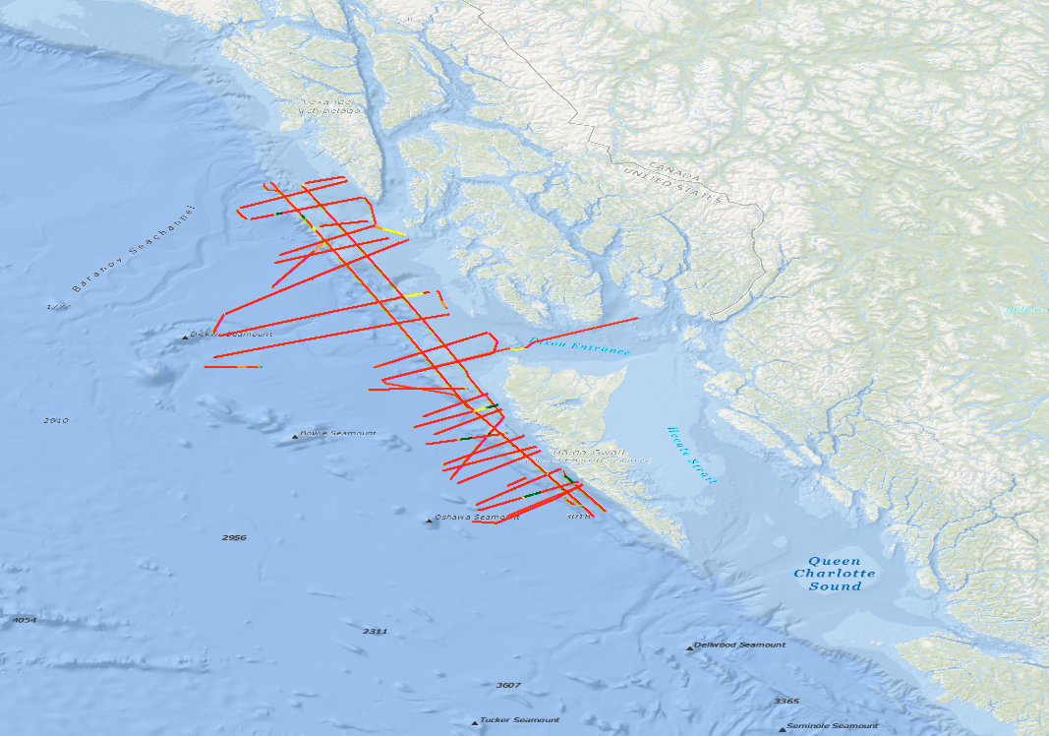
Figure 1. Location of track lines and volume of source of the marine geophysical survey.

Energy Source and Receiving Systems
The energy source utilized during the surveys consisted of four towed acoustic source sub-arrays, each with nine source elements (for a total of 36 source elements), deployed just aft of the vessel. The source array utilized Bolt 1500LL and Bolt 1900LLX elements ranging in size from 40 to 360 cubic inches (in³), with an operating pressure of 1950 pounds per square inch. The dominant frequency components ranged from two to 188 Hertz (Hz) and nominal source levels ranged from 258 dB re: 1 μPa (zero to peak) to 264 dB re: 1 μPa (peak-to-peak). The source elements were towed at a depth of 12 meters, and the center of the source was situated 230 meters from the Navigation Reference point (NRP), which was located on the PSO observation tower. This positioned the first elements on the arrays 193 meters from the stern of the vessel.

The maximum source volume utilized during the survey was 6600 in³ with 36 active elements. During times when acoustic source arrays were brought on board for maintenance or repair, the total source volume was reduced to varying lower volumes depended on how many of the elements and arrays were disabled. The shot point interval was 37.5 meters (approximately every 123 seconds) During acquisition the source elements would emit a brief (approximately 0.1 second) pulse of sound. During the intervening periods of operations, the source elements would be silent.

The receiving system for the survey consisted of one hydrophone streamer and OBSs. From 25 July 2021 to 21 August 2021, the hydrophone streamer was configured to a length of 15 kilometers. On 11 August, the streamer was recovered to perform maintenance on forward sections. It was redeployed on 12 August. As the acoustic source array was towed along the track lines, the hydrophone streamer received the returning acoustic signal and transferred the data to the on-board processing system. The long streamer lengths allow for more accurate measurements of seismic velocities and provide a large amount of data redundancy for enhancing seismic images during data processing.

The OBSs consisted of short-period multi-component OBSs and broadband instruments. The OBSs were deployed at either five or 10-kilometer spacing along five OBS refraction lines, fault location dependent. Of the five OBS survey lines, two were parallel and three were perpendicular to the coasts. The three perpendicular lines were located off Southeast Alaska, Haida Gwaii Island and in Dixon Entrance. Following the completion of a refraction line, R/V Tully would recover, service, and redeploy OBSs on subsequent refraction survey lines. The OBSs receive and store the returning acoustic signals internally for later analysis. Seismometers were also deployed on land along the survey area for a complementary land-based research effort conducted by the Geologic Survey of Canada to expand the geophysical dataset available for analysis for the Queen Charlotte region.

Additional sound sources included a Kongsberg EM 122 multi-beam echosounder (MBES), Knudsen Chirp 3260 sub-bottom profiler (SBP), and a Teledyne RDI 75 kHz Ocean Surveyor acoustic Doppler current profiler (ADCP). The hull mounted MBES operated at frequencies between 10.5 and 13 (usually 12) kilohertz. Each ping consisted of eight (in water depths greater than 1000 meters) or four (in water depths less than 1000 meters) successive fan-shaped transmissions. The transmitting beam width was one or two degrees fore-aft and 150 degrees perpendicular to the ship’s line of travel. The maximum source level was 242 dB re: 1 μPa (root mean square [rms]). The hull-mounted SBP beam was transmitted as a 27-degree cone, which was directed downward by a 3.5 kilohertz transducer. The nominal power output was 10 kilowatts; however, the actual maximum radiated power was three kilowatts or 222 dB re: 1 μPa m (rms). The ping duration was 64 seconds, and the interval was one second. The hull-mounted ADCP operated at a frequency of 75 kilohertz and a maximum source level of 224 dB re: 1 μPa m (rms) over a conically shaped 30-degree beam. The MBES and SBP operated simultaneously to provide information about near sea floor sedimentary features and to map the topography of the ocean floor. The ADCP was used to measure water current velocities.

Mitigation and monitoring Methods
The PSO monitoring program on R/V Langseth was established to meet the standards set forth in the PEIS, EA, NMFS and FWS IHAs, and BiOp, LOC, and DFO LOA requirements. Survey mitigation measures were designed to minimize potential impacts of R/V Langseth’s seismic activities on marine mammals, sea turtles, and other protected species of interest. The following monitoring protocols were implemented to meet these objectives.

- Visual observations were conducted to provide real-time sighting data, allowing for the implementation of mitigation procedures as necessary.
- A Passive Acoustic Monitoring system was operated 24 hours a day to augment visual observations and provide additional marine mammal detection data.
- Effects of marine mammals and sea turtles exposed to sound levels constituting a take were observed and documented. The nature of the probable consequences was discussed when possible.

In addition to the mitigation objectives outlined in the PEIS, EA, IHAs, BiOp, LOC, and DFO LOA, PSOs collected and analyzed necessary data mandated by the IHAs (see Appendix A and Appendix B).

Mitigation Methodology
Mitigation actions were implemented for visual and acoustic detections of protected species, including marine mammals, sea turtles, and protected sea birds, as outlined in the EA, IHAs, BiOp, LOC, and DFO LOA. These actions included the establishment of BZs and EZs, and the implementation of delayed operations, power-downs (during which the source volume was reduced to a single active 40 in³ element), and shut-downs (during which the source was fully silenced) for protected species detected approaching, entering, or within their designated BZ and EZ.

Before the acoustic source could be activated from silence (day and night), two PSOs and one PAM operator conducted a clearance survey of the buffer and exclusion zones. The length of the clearance survey was 30 minutes in US EEZ and 60 minutes in Canadian EEZ. In the event of a detection of protected species within their designated zones (Table 2) or as outlined in Table 1, a delay of source operations would be implemented. Source operations would not be cleared to begin until the protected species were observed exiting their designated zones. In US EEZ, if the protected species were not observed exiting their designated zones (i.e., if they dove/submerged within the zone and were not re-sighted), operations would not be cleared to begin until a specific time following the final detection of the animals. For detections of small odontocetes, pinnipeds, sea otters, sea turtles, or sea birds, this time was 15 minutes following last sighting in the US EEZ. For detections of mysticetes and other large odontocetes (including sperm whales, beaked whales, killer whales and Risso’s dolphins) this time was 30 minutes following last sighting in US EEZ. In the Canadian EEZ, this time was 60 minutes following the last sighting of the individuals within their designated zones for all species.

Once the acoustic source was active, the BZ from any element on the acoustic source arrays were established as areas in which the presence of a protected species would initiate an alert to the seismic operators that the animal was detected, and that the implementation of a mitigation action may soon be required. PSOs and the PAM operator would keep in frequent contact with each other and the seismic team, relaying information on the location and movement of the protected species, and the implementation of any needed mitigation actions.

The EZs from any active source element were established as areas in which the detection of a protected species would trigger a power-down or a shut-down of the acoustic source, depending on the species present. For marine mammals, the detection of one approaching, entering, or within their designated zone would trigger a shut-down of the source in both US and Canadian EEZs. For sea turtles, the detection of one approaching, entering, or within the 500-meter or 100-meter exclusion zones would trigger a power-down or a shut-down of the source, respectively, in the US EEZ. In Canadian EEZ, the exclusion zone for sea turtles was 1000-meters where a shut-down would be implemented. For protected sea birds, the detection of one foraging or diving within the 500-meter or 100-meter exclusion zone would trigger a power-down or a shut-down of the source, respectively, in both US and Canadian EEZs.

Upon the implementation of a power-down for a detection of sea turtles in the US EEZ only, source activity could be resumed at the previous operating volume once the exclusion zones were confirmed to be clear of the protected species. Upon the implementation of a power-down for a detection of protected sea birds in both US and Canadian EEZs, source activities could be resumed at the previous operating volume once the exclusion zones were confirmed to be clear of the protected species. Upon the implementation of a shut-down for a detection of protected species, a ramp-up was required to resume source activity once the protected species were confirmed to have exited their respective exclusion zones. For both power-downs and shut-downs, if the protected species could not be confirmed to have exited their respective exclusion zones (i.e., if they submerged/dove within the zone and were not re-sighted), clearance for source activity to resume would not be given until a specific time following the last sighting of the individuals within the zones. For detections of small odontocetes, pinnipeds, sea otters, sea turtles, or sea birds, this time was 15 minutes following last sighting in US EEZ. For detections of mysticetes and other large odontocetes (including sperm whales, beaked whales, killer whales, and Risso’s dolphins) this time was 30 minutes following last sighting. In Canadian EEZ, this time was 60 minutes following the last sighting of the individuals within their designated zones for all species.

The IHAs, BiOp, and DFO LOA also outlined additional mitigation actions of specific protected species while the acoustic source was active as outlined in Table 1. The shut-down requirement was waived for small dolphins in the genera Lagenorhynchus, and Lissodelphis in US EEZ only. If PSOs could identify the dolphins sighted as one of these species, no mitigation action was required if they were observed approaching, entering, or within the 500-meter exclusion zone. If there was any uncertainty regarding the species identification, visual PSOs were to use their best professional judgment in making the decision to call for a shut-down.

Table 1: Specific detections of protected species and their required mitigation actions.
Detection of: | Mitigation Action Required | EEZ
A North Pacific right whale observed at any distance from the vessel. | Delayed operation of inactive source and shutdown of active source. | US & Canada
A large whale (defined as a sperm whale or any mysticete species) with a calf (defined as an animal less than two-thirds the body size of an adult and observed in close association with an adult) observed at any distance from the vessel. | Delayed operation of inactive source and shutdown of active source. | US & Canada
An aggregation of six or more large whales observed at any distance from the vessel. | Delayed operation of inactive source and shutdown of active source. | US & Canada
Any marine mammal species not authorized for take observed approaching, entering, or within the 160-decibel radius. | Delayed operation of inactive source and shutdown of active source. | US
Any marine mammal species for which the total authorized takes has been met observed approaching, entering, or within the 160-decibel radius. | Delayed operation of inactive source and shutdown of active source. | US
Any other protected species detected approaching, entering, or within their designated buffer zones. | Delayed operation of inactive source and a warning call that a mitigation action may soon be required for an active source. | US & Canada
Any other protected species detected approaching, entering, or within their designated exclusion zones. | Delayed operation of inactive source and shutdown of active source. | US & Canada
Any dolphin species with a shut-down exemption detected approaching, entering, or within their designated exclusion zones. | None. | US

Table 2: Separation distances, and buffer and exclusion zone sizes for each species/species group expected to occur in the survey area.
Species/Species Groups | Separation Distances |  | Buffer Zones |  | Exclusion Zones
 | US | Canada | US | Canada | US | Canada
North Pacific Right Whale | 500m | 500m | Any Distance | Any Distance | Any Distance | Any Distance
Mysticetes | 100m | 100m | 1000m¹ | 1000m¹ | 500m¹ | 1000m¹
Sperm Whale | 100m | 100m | 1000m¹ | 1500m¹ | 500m¹ | 1500m¹
Beaked Whales and Pygmy and Dwarf Sperm Whales | 50m | 100m | 1500m | 1500m | 1500m | 1500m
Killer Whales | 50m | 50m | 1000m | Any Distance | 500m | Any Distance
Delphinid/Porpoise | 50m | 100m | 1000m | 1000m | 500m² | 1000m
Pinnipeds | 50m | 50m | 1000m | 1000m | 500m | 1000m
Sea Turtle | 50m | 50m | 175 dB radius | 1000m | 500m/ 100m³ | 1000m
Sea Otter | 50m | 50m | 1000m | 1000m | 500m | 500m
ESA Sea Bird | None | None | N/A | N/A | 500m/ 100m³ | 500m/ 100m³
¹For these species, sightings of an aggregation of six or more individuals or an adult with a calf have buffer and exclusion zones of any distance.
²Except exempt species per the NMFS IHA, only in US waters.
³For these species, a power-down is implemented at the 500m exclusion zone while a shutdown is implemented at the 100m exclusion zone.

Specific acoustic source operation procedures outlined in the IHAs, BiOp included:
- Ramp-ups could not be less than 20 minutes and were required to begin with the smallest volume element and continue in stages by doubling the number of active elements, with each stage approximately the same duration.
- Brief periods (less than 30 minutes) of operational silence for reasons other than a protected species shut-down did not require a ramp-up to resume full volume source operations provided that: (1) PSOs maintained constant visual and/or acoustic observation, and (2) no visual or acoustic detections of protected species occurred within the applicable exclusion zone during that silent period. For any brief period of silence at night or in periods of poor visibility (e.g., BSS of four or greater), a ramp-up was required, but if constant observation was maintained, a pre-start clearance watch was not required. For any longer shut-down, both a pre-start clearance watch and a ramp-up were required.
- No survey operations were allowed in waters less than 100 meters in depth within Canadian EEZ.
- Seismic activities could not be conducted in the Canadian designated Killer Whale Critical Habitat (KWCH), and the 160-decibel radius (Level B zone for marine mammals) could not enter the habitat.

Specific acoustic source operation procedures outlined in the DFO LOA included:
- Conduct seismic survey activities outside of designated Northern Resident Killer Whale Critical Habitat (KWCH) with a setback that ensures that the estimated sound pressure level has diminished to ≤160 dB RMS re: 1 μPa for the shortest distance to the boundary of KWCH.
- Initiate an immediate and complete shutdown of the airgun array if a Killer Whale (all ecotypes), Northern Pacific Right Whale, whale with calf (any species) or aggregation of whales (any species) is observed.
- Initiate an immediate and complete shutdown of the airgun array if a Sperm Whale or a beaked whale (any species) is sighted within 1500 m of the airgun array.
- For other observations of marine mammals and/or turtles, initiate an immediate and complete shutdown of the airgun array if these animals are observed within an established exclusion zone with a radius of 1000 m.
- Avoid conducting seismic surveys within the following conservation areas: Gwaii Haanas National Marine Conservation Area Reserve and Haida Heritage Site, Duu Guusd Heritage Site / Conservancy, and Daawuuxusda Heritage Site / Conservancy.
- Refrain from conducting seismic surveys in waters less than 100 m in depth. Although this was requirement, it ws not implemented because activities did not occur in <200m water depth.
- Conduct seismic surveys in waters 100 to 200 m deep during daylight hours only, with a second vessel having two marine mammal observers on watch, positioned 5 km ahead of the R/V Langseth.
- Combine enhanced visual observations (e.g., reticle and big-eye binoculars, night vision devices and digital cameras) with non-visual detection methods (e.g., infrared technology (FLIR) and passive acoustic monitoring) to increase the likelihood of detecting marine mammals during ramp up, Beaufort sea states >3, and during night time survey operations.
- Monitor the established exclusion zone with a radius of 1000 m for 60 minutes prior to initial start-up of the airgun array or resumption of operations following a complete shutdown to allow for the detection of deep diving animals.

Table 3 describes the predicted 160 decibel radius (Level B harassment zone for marine mammals) and the predicted 175 decibel radius (Level B harassment zone for sea turtles). Table 4 describes the predicted Level A harassment zones for each protected species hearing group per the NMFS guidelines, and the species that could occur in the survey area assigned to each group; as noted previously however, shut-downs would occur at each species designated EZs (e.g., 500-meters, 1500-meters, etc.).

Table 3: Predicted 160/175/195 Decibel Zones* Implemented during the survey.
Source | Volume (in³) | Water Depth (m) | 160 dB radius – Level B harassment zone for marine mammals | 175 dB radius – Level B harassment zone for sea turtles
1 element | 40 | >1,000 | 431 | 77
 |  | 100-1000 | 647 | 116
 |  | <100 | 1041 | 170
36 Elements | 6600 | >1,000 | 6733 | 1864
 |  | 100-1000 | 9468 | 2542
 |  | <100 | 12650 | 3924
*Distances are from any single element on the array

Table 4: Predicted Level A Harassment Zones* for each Marine Mammal Hearing Group Implemented during the survey.
Source | Volume (in³) | Low Frequency Cetaceans (m) | Mid Frequency Cetaceans (m) | High Frequency Cetaceans (m) | Phocid Pinnipeds (m) | Otariid Pinnipeds/Sea Otters (m) | Sea Turtles (m)
36 elements | 6600 | 320.2 | 13.6 | 268.3 | 43.7 | 10.6 | 20.5
Species anticipated that could occur in the survey area:  *Distances are from any single element on the acoustic source arrays  *Shut-downs occur at each species relevant zones (i.e., 1500 meters, 500 meters, 100 meters)  Dolphin species in blue text are the shut-down exemption species in US EEZ. |  | - North Pacific Right Whale  - Humpback Whale  - Blue Whale  - Fin Whale  - Sei Whale  - Minke Whale  - Gray Whale | - Sperm Whale  - Baird’s Beaked Whale  - Cuvier’s beaked whale  - Stejneger’s beaked whale  - Pacific White-sided Dolphin  - Northern Right-whale Dolphin  - Risso’s Dolphin  - Killer Whale | - Dall’s Porpoise  - Harbor Porpoise | - Northern Elephant Seal  - Harbor Seal | - Northern Fur Seal  - California Sea Lion  - Steller Sea Lion  - Northern Sea Otter | - Leatherback Sea Turtle

Visual Monitoring Survey Methodology
There were five experienced PSOs on board R/V Langseth during the survey to conduct monitoring for protected species, record and report detections, and request mitigation actions in accordance with the PEIS, EA IHAs, BiOp, and DFO LOA. The PSOs on board were NMFS approved and held certifications from a recognized Bureau of Ocean Energy Management (BOEM) course. Visual monitoring was primarily carried out from an observation tower (Figure 2) located 18.9 meters above the surface of the water, which allowed a 360-degree viewpoint around the vessel and acoustic source.
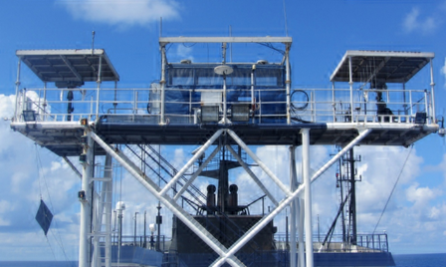
Figure 2. Protected Species Observer stern view of observation tower with mounted big-eye binoculars.

The PSO tower was equipped with Fujinon 7x50 and Steiner Marine 7x50 binoculars, as well as two mounted 25x150 Big-eye binoculars for visual monitoring. A D-300-2MS Night Optics USA, Inc. monocular and two Butler Creek PVS-7-night vision devices were also available for visual monitoring during reduced/restricted lighting conditions if needed. Inside the tarpaulin tent the PSOs were provided a laptop, a telephone for communication with the PAM station, bridge, and main lab, and a monitor that displayed pertinent information about the vessel including position; speed; heading; water depth; sea temperature; wind speed and direction and air temperature. Monitor also displaced source activity information including survey line number, total number of active elements and volume. Environmental conditions along with vessel and acoustic source activity were recorded at least once an hour, or every time there was a change in one or more of the above variables. Most visual monitoring was held from the tower; however, during severe weather or when the ships exhaust was blowing on the tower, monitoring would be conducted from the bridge (approximately 12.8 meters above sea level) or the catwalk (approximately 12.3 meters above sea level).

Visual monitoring methods were implemented in accordance with the survey requirements outlined in the IHAs and ITS. Two PSOs visually monitored for protected species during daylight hours throughout the survey, from port to port. Visual monitoring during the transits between the ports and the survey area were conducted for vessel strike avoidance of or protected species. Visual monitoring during periods of acoustic source silence was conducted to gather baseline data on the presence and abundance of protected species in the areas. Throughout the survey, visual monitoring was conducted each day from 30 minutes before sunrise until 30 minutes after sunset as required by the IHAs and BiOp. Observation times ranged between 12:04 to 05:45 Coordinated Universal Time (UTC). Scheduled watches were a maximum of four hours in duration followed by at least one hour of scheduled break time.

Visual observations were conducted around the entire area of the vessel and acoustic source, divided between the two PSOs on watch. The smaller monitoring area for each observer increased the probability of protected species being sighted. PSOs searched for blows, fins, splashes or disturbances of the sea surface, large flocks of feeding sea birds, and other sighting cues indicating the possible presence of a protected species. Upon the visual detection of a protected species, PSOs would identify the animals’ range to the vessel and acoustic source. Range estimations were made using reticle binoculars, the naked eye, and by relating the animal(s) to an object at a known distance, such as the acoustic source arrays and streamer head float. PSOs would also identify to species, if possible, upon initial detection to ensure that the proper mitigation measures were implemented, should any be required.

As required by the IHA (section 5(d)(iii)), PSOs recorded the following information for each protected species detection:
- Date, time of first and last sighting, observers on duty during the detection, location of the observers, vessel information (e.g., position, speed, heading), water depth, and acoustic source activity (e.g., volume and number of active elements).
- Species, detection cue, group size (including number of adults, juveniles, and calves), visual description (e.g., overall size, shape of the head, position and shape of the dorsal fin, shape of the flukes, height and direction of the blow), observed behaviors (e.g., porpoising, logging, diving, etc.), and the initial and final pace, heading, bearing, and direction of travel in relation to both the vessel and the source (e.g., towards, away, parallel, perpendicular, etc.).
- Initial, closest, and final distance to the vessel and the source, time when entering and exiting the EZs, type of mitigation action implemented, total time of the mitigation action, description of other vessels in the area, and any avoidance maneuvers conducted.

During or immediately after each sighting event, the PSOs recorded the detection details per the requirements of the IHA and BiOp in a detection datasheet. Each sighting event was linked to an entry on an effort datasheet where specific environmental conditions (e.g., Beaufort Sea state, wind force, swell height, visibility, and glare) and vessel activity were also logged.

Species identifications were made whenever possible during detections, photographs were taken with two vessels provided Canon EOS 80D cameras that had 300-millimeter lenses. Marine mammal identification manuals were consulted, and photos were examined to confirm identifications.

passive Acoustic Monitoring Survey Methodology
Passive Acoustic Monitoring (PAM) was used to augment visual monitoring efforts in the detection, identification, and locating of marine mammals. PAM was very important during periods of time when visual monitoring was not effective (periods of darkness or low visibility). Acoustic monitoring was conducted continuously during all seismic operations and to the maximum extent possible during periods of acoustic source silence. When the acoustic source was activated from any period of silence, acoustic monitoring was conducted for at least 30 or 60 minutes prior to the activation of the source for the pre-clearance survey, dependent on the area operations would take place. PAM shifts were a maximum of four hours in duration followed by at least one hour break.

In accordance with the IHA and BiOp, in the event of an issue with PAM equipment, acoustic source activity could continue for 30 minutes without acoustic monitoring while the PAM operator diagnosed the issue. If the diagnosis indicated that the PAM system needed maintenance, operations could continue for an additional five hours without acoustic monitoring, during daylight hours only, provided that: (1) the sea state was less than or equal to a BSS 4; (2) with the exception of delphinids (other than killer whales), no marine mammals were acoustically detected in the applicable exclusion zones in the previous two hours; (3) active acoustic source operations without acoustic monitoring did not exceed a cumulative total of five hours within any 24 hour period; and (4) NMFS was notified via email as soon as practicable of the time and location in which operations occurred without an active PAM system.

The PAM system was located in the main science lab which allowed ample space, quick communication with the PSOs and seismic technicians, and access to the vessel’s instrumentation screens. Information about the vessel (e.g., position, heading, and speed), water depth, source activity (e.g., line number, total source volume, number of active elements), and the PAM system (e.g., cable deployments/retrievals, changes to the system, background noise score, hydrophone depth) were recorded at least once an hour, or whenever any of the parameters changed.

Acoustic monitoring for marine mammals was conducted aurally, utilizing Sennheiser headphones, and visually with the Pamguard software program. Low frequency (LF) to mid-frequency delphinid whistles, clicks, and burst pulses, as well as sperm whale clicks and baleen whale vocalizations, could be visualized in Pamguard’s spectrogram modules. Sperm whale, beaked whale, kogia species, and delphinid clicks could also be visualized in LF and HF click detector modules. Settings adjustments to amplitude range, amplitude triggers, and spectral content filters, among others, could be made in Pamguard’s spectrogram and click detector modules to maximize the distinction between cetacean vocalizations and ambient signal. The map module within Pamguard could be utilized to attempt localizing the position and range of vocalizing marine mammals. Sound recordings could be made using the HF and LF sound recording modules when potential marine mammal vocalizations were detected, or when the operator noted unknown or unusual sound sources.

As required by the IHA (section 5(d)(iv)), PAM operators recorded the following information during acoustic detections of protected species:
- Date, time of first and last detection, operator on duty, linked to a visual sighting, vessel information (e.g., position, speed, heading), water depth, and acoustic source activity (e.g. volume and number of active elements).
- Species (if determinable), group size, methods/modules on which vocalizations were detected during the event, and vocalization characteristics (e.g., signal type, frequency and amplitude range, inter-click interval, patterns, etc.)
- Determinable bearings (to the hydrophones, vessel, and source) estimated and/or attempted localizations and any ranges determined, type and time of any implemented mitigation actions and any resulting production loss.

Passive Acoustic Monitoring Parameters
A PAM system designed to detect most species of marine mammals was installed on board R/V Langseth. The system was developed by Seiche Measurements Limited and consisted of the following main components: a 250 meter hydrophone cable (configured as a separate 230 meter steel-reinforced tow cable and detachable 20 meter hydrophone array); a 100 meter deck cable; a rack-mounted electronic processing unit (EPU) that incorporated a buffer unit, RME Fireface 800 unit and computer; two desktop monitors; a keyboard and mouse; acoustic analysis software package; and headphones for aural monitoring. A complete spare system of all components was also present on board in the event that any of the main system components became damaged or inoperable. The diagram in Figure 3 is a simplified depiction of the PAM system installed on R/V Langseth, and further PAM system specifications can be found in Appendix D.
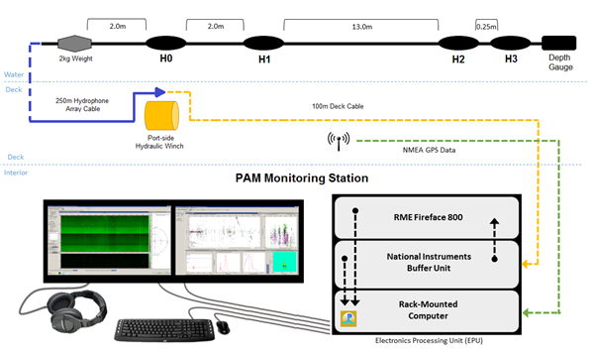
Figure 3: Simplified pathway of data through the PAM system on board the Langseth.

The hydrophone cable contained four hydrophone elements and a depth gauge molded into a 20-meter section of the cable. The four-element linear hydrophone array allowed the system to sample a large range of marine mammal vocalization frequencies. The first two hydrophones (H0 and H1) were broadband elements, with a frequency response of 200 hertz to 200 kilohertz. The third and fourth hydrophones (H2 and H3) were standard elements, with a frequency response of two kilohertz to 200 kilohertz
.
The deck cable interfaced between the hydrophone cable deployed astern of the vessel and the electronics processing unit (EPU) located in the main science lab. The rack-mounted EPU was set up with the two pre-installed, wall-mounted monitors supplied by the Langseth, a keyboard, a mouse, and headphones. The EPU contained a buffer unit with Universal Serial Base (USB) output, an RME Fireface 800 ADC unit with firewire output, and a rack-mounted computer. A Global Positioning System (GPS) feed of GNGGA strings was supplied from the ship’s Seapath navigation system and routed to the computer, reading data every five seconds. Data from the hydrophone cable’s depth transducer was routed through the buffer unit to the computer, via USB connection. Pamguard Beta version 1.15.11 was the software version utilized for the surveys.

Raw feed from the two standard hydrophone elements (H2 and H3) was digitized in the buffer unit using an analogue-digital National Instruments data acquisition (DAQ) soundcard at a sampling rate of 500 kilohertz. The output was filtered for HF content and visualized using the Pamguard software. Clicks were measured at sixth order (Butterworth) with a high-pass digital pre-filter of 30 kilohertz and a high-pass trigger filter of 40 kilohertz. Pamguard used the difference between the time that a signal arrived at each of the two hydrophones to calculate and display the bearing to the source of the signal. A scrolling bearing/time module displayed the filtered data in real time, allowing for the detection and directional mapping of click trains. Additional components of the HF click detector system in Pamguard included: an amplitude/time display that registered click intensity data in real time, as well as click waveform, click spectrum, and Wigner plot displays, providing the PAM operator immediate review of individual click characteristics in the identification process.

Raw feed from the two broadband hydrophone elements (H0 and H1) was routed from the buffer unit to the RME Fireface 800 unit, where it was digitized at a sampling rate of 48 kilohertz. The relatively low frequency (LF) output was further processed within Pamguard by applying Engine Noise Fast Fourier Transform (FFT) filters, including click suppression and spectral noise removal filters (e.g., median filter, average subtraction, Gaussian kernel smoothing and thresholding). Filtered LF content was visualized in two spectrograms, one displaying a channel feed at frequency ranges of zero to 24 kilohertz, and another displaying a channel feed at a frequency range of zero to three kilohertz. LF click detector modules allowed for review of individual click characteristics as well as the detection and tracking of click trains.

A map module on the LF system interfaced with GPS data provided by the vessel to display the vessel location and could be used to determine range and bearing estimates based on clicks tracked in the click detector module. Pamguard contained a function for calculating the range to vocalizing marine mammals based upon the least squares fit test. This method is most effective with animals that are relatively stationary in comparison to the moving vessel, such as sperm whales. The mathematical function estimated the range to vocalizing marine mammals by calculating the most likely crossing of a series of bearing lines generated from tracked clicks or whistles and plotted on a map display. The bearings of detected whistles and moans were calculated using a Time-of-Arrival-Distance (TOAD) method (where the signal time delay between the arrival of a signal on each hydrophone was compared), and presented on a radar display, along with amplitude information for the detected signal as a proxy for range.

Additional modules displayed on the LF monitor included a LF sound recorder and clip generator. The clip generator module within Pamguard could be used to generate short sound clips in response to either an automatic detection or the operator manually selecting a portion of the spectrogram display. This module was useful in the event that the whistle-and-moan detector falsely triggered and identified a non-biological sound (i.e. echosounder) or if it missed detecting tonal signatures that the operator determined to be vocalizations.

Hydrophone Deployment
The hydrophone cable was deployed from a hydraulic winch on the port stern of the vessel’s aft deck where the acoustic source arrays were deployed. Two deck cables, a main and a spare, were installed along the deck-head running from the winch to the main science lab. A Chinese finger attached to the tow cable approximately 120 meters ahead of the connector to the hydrophone array was secured to the port side boom via lifting rope. This reduced the tension on the cable remaining on the winch, and also served as a method to pull the cable further to port and away from the source arrays. This deployment method placed the trailing end of the hydrophone cable approximately 120 meters from the port stern of the vessel, and approximately 73 meter forward of the first elements on the acoustic source arrays (Figure 4). Two pieces of chain, seven kilograms each, were attached and secured to the tow cable to increase tow depth and to decrease the chance of entanglement with the source arrays’ umbilicals. The tow depth of the hydrophones varied between 8 and 12.6 meters and averaged 10.7 meters throughout the survey.

A more detailed description of the hydrophone deployment method can be found in Appendix E.

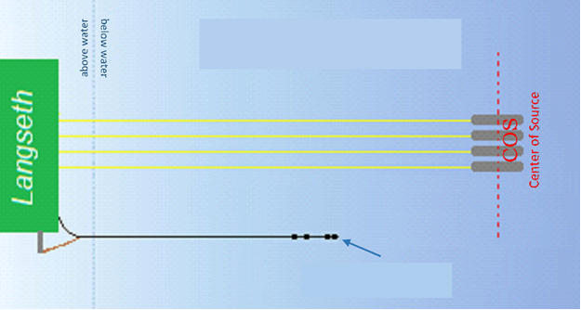
First elements on the arrays 193 meters astern (COS 201 meters astern)
End of hydrophone cable 120 meters astern
Figure 4. Location of the PAM cable in relation to the seismic gear during the survey.

Monitoring Effort Summary

Survey Operations Summary

General survey parameters
The Queen Charlotte Fault seismic survey began on 18 July 2021 when R/V Langseth departed port in Seattle, Washington and concluded on 23 August 2021 when R/V Langseth arrived at port in Ketchikan, Alaska (Table 5).

Table 5: Survey parameters
Survey Parameter | Date | Time (UTC) | Location
Langseth
Mobilization | 18 July 2021 | 16:35 | Seattle, Washington
First Source Activity | 20 July 2021 | 19:03 | Survey area
Start of Acquisition | 20 July 2021 | 19:29 | Survey area
End of Acquisition | 21 August 2021 | 01:19 | Survey area
Demobilization | 23 August 2021 | 16:00 | Ketchikan, Alaska

During the survey, data was acquired continuously according to the survey plan, with source operations only suspended when operationally necessary, as outlined in Table 6. There were two instances, on 21 and 28 July 2021, when shut-downs (Visual Detection #s 36 and 84) for a protected species was implemented just before dark and due to nighttime monitoring requirements, a ramp-up of the source was unable to be cleared until the following day at day-light. These shut downs resulted in nine hours one minute and eight hours 28 minutes, respectively, of source operations being suspended.

Table 6: Suspension of source operations during the survey.
Date | Time Source silenced | Date | Time Source Re-activated | Reason for Interruption in Acquisition
23 July 2021 | 13:25 | 24 July 2021 | 14:41 | Seismic gear was retrieved for transit to next survey line
24 July 2021 | 23:20 | 25 July 2021 | 17:26 | Deploying streamer
06 August 2021 | 10:52 | 06 August 2021 | 14:53 | Source disabled for maintenance
08 August 2021 | 20:04 | 08 August 2021 | 21:27 | Source disabled due to water depth <200 meters in Canada’s EEZ
09 August 2021 | 17:21 | 09 August 2021 | 20:22 | Source disabled due to water depth <200 meters in Canada’s EEZ
11 August 2021 | 14:53 | 12 August 2021 | 04:35 | Streamer maintenance
19 August 2021 | 13:55 | 20 August 2021 | 01:52 | Source disabled due to line change
20 August 2021 | 10:32 | 20 August 2021 | 19:22 | Source disabled due to line change

MBES, SBP and ADCP operations
The multi-beam echosounder (MBES), sub-bottom profiler (SBP), and the acoustic Doppler current profiler (ADCP) systems were active throughout the majority of the survey while the vessel was within the survey area for a total of 767 hours 30 minutes. The sound sources were active for the first time on 20 July 2021 at 15:55 (SBP), and 15:55 UTC (ADCP) and on 21 July 2021 at 05:24 (MBES). All three sound sources were de-activated for the survey on 21 August 2021 at 15:25 UTC.

Acoustic source operations
The acoustic source was active for a total of 622 hours 23 minutes throughout the survey. This total included: 10 hours 15 minutes of ramp-up, 552 hours 59 minutes of operations on a survey line (454 hours 24 minutes at full volume and 98 hours 35 minutes at reduced volumes),58 hours 46 minutes of operations not on a survey line (52 hours 26 minutes at full volume and six hours 20 minutes of reduced volumes), and 23 minutes of source testing.
Table 7 summarize the acoustic source operations over the course of the seismic survey.

The acoustic source was ramped-up 30 times over the course of the survey, including 10 times to commence source operations from a period of silence and 20 times to resume source operations from a mitigation shut-down for protected species. 29 ramp-ups were conducted during daylight hours and one ramp-up was conducted during hours of darkness. All ramp-ups were cleared by both visual and acoustic monitoring. Ramp-ups ranged averaged 21 minutes in duration and were conducted using the automated controller program, Gun Link 2000, which added source elements sequentially to achieve the full source volume over the required period.

There were no operations with only a single 40 in³ source element conducted for protected species mitigation power-downs during the survey.

There was one occasion of source testing totaling 23 minutes during the survey consisting of a single source test.

Table 7. Total acoustic source operations during the seismic survey.
Acoustic Source Operation | Number | Duration
Source Tests | 1 | 00:23
Ramp-up | 30 | 10:15
Day-time ramp-ups from source silence | 29 | 09:54
Night-time ramp-ups from source silence | 1 | 00:21
Full (6600 in³)/Reduced Volume on a Survey Line¹ |  | 552:59
Full (6600 in³)/Reduced Volume not on a Survey Line² |  | 58:46
Single Source Element (40 in³) |  | 00:00
Total Time Acoustic Source Was Active |  | 622:23
- On a Survey Line: 454:24 (full volume), 98:35 (reduced volume)
- Not on a Survey Line: 52:26 (full volume), 06:20 (reduced volume)

The geospatial data for source operations conducted during the survey are provided as a shapefile attachment to this report. Throughout the survey, the volume of the acoustic source was changed (reduced or increased) on multiple occasions during active source operations, mainly due to issues with individual source elements and maintenance of the acoustic source arrays.

Interactions with Other Vessels
In addition to visually monitoring for protected species, PSOs also observed and documented interactions with other marine vessel traffic. Such interactions included, but were not limited to another vessel or another vessels’ towed gear/equipment interacting with R/V Langseth’s towed gear/equipment, and R/V Langseth having to deviate from planned survey operations (i.e. diverge from the survey line, increase/decrease speed) because of another vessel.

Over the course of the survey, there were no instances where R/V Langseth had such an interaction with another vessel.

Visual Monitoring Survey Summary
Visual monitoring was conducted by two PSOs during all daylight hours throughout the survey, beginning 30 minutes before sunrise and ending 30 minutes after sunset each day, initiating when the vessel left the port at the beginning of the project and terminating upon the vessels return to port at the end of the project (Table 8). This included times when the vessel was in transit and deploying and retrieving equipment. Visual monitoring during transit was conducted for vessel strike avoidance, and visual monitoring during times with no source operations was conducted to collect baseline data about protected species abundance in the survey areas.

Table 8: Initiation and termination of visual monitoring during the survey.
Visual Monitoring | Date | Time (UTC)
Langseth
Initiation for the survey | 18 July 2021 | 16:35
Termination for the survey | 23 August 2021 | 16:00

Visual monitoring on R/V Langseth was conducted over a period of 37 days for a total of 571 hours 11 minutes. Of the overall total visual monitoring effort, 74% was undertaken while the acoustic source was active, and 26% was undertaken while the acoustic source was silent. Visual monitoring while the acoustic source was silent was mainly conducted during the transits to and from the survey sites, and during equipment deployment, recovery, and maintenance. Table 9 details visual monitoring with acoustic source operations on the Langseth throughout the survey. On 21 August at 16:21 UTC, visual monitoring during transit after completion of the survey was suspended due to weather and safety concerns. Monitoring resumed on 23 August at 13:05 UTC until the vessel was alongside in Ketchikan, Alaska at 16:00 UTC that day.

Table 9. Total visual monitoring effort during the survey.
Visual Monitoring Effort | Duration (hh:mm) | % of Overall Visual Monitoring Effort
Total monitoring while acoustic source active | 421:50 | 74
Total monitoring while acoustic source silent | 149:21 | 26
Total monitoring effort | 571:11 | 100

Visual observations on R/V Langseth were preferentially conducted from the PSO tower, which provided a 360-degree view of the water around the vessel and the acoustic source. Visual watches were conducted from other locations, including the catwalk, bridge, and stern if monitoring conditions could not be undertaken from the tower, such as during rough weather and sea conditions which made the tower unsafe, or when the vessel was heading directly into the wind, blowing the engine exhaust onto the tower. PSOs conducted visual monitoring from the tower (82%) and from the bridge (18%) more often than any other location during the survey (Table 10). Monitoring was conducted simultaneously from the bridge and catwalk when the ships exhaust was blowing on the tower but monitoring conditions were otherwise favorable. Monitoring was conducted simultaneously from the tower and catwalk when the ships exhaust was only blowing on part of the tower.

Table 10: Total visual monitoring effort from observation locations during the survey.
Observation Location During Visual Effort | Duration (hh:mm) | % of Overall Effort
Tower | 476:10 | 82
Bridge | 95:01 | 18

Acoustic Monitoring Survey Summary
Acoustic monitoring during the survey was conducted continuously throughout acoustic source operations and to the maximum extent possible while the acoustic source was silent (Table 11). Brief periods of source activity without acoustic monitoring were conducted for any needed assessments, adjustments, or maintenance to the PAM system. Periods without source activity or acoustic monitoring occurred when the PAM hydrophone cable was secured on board the vessel during transits, during deployment and recovery of the seismic gear, and during times when operations were suspended due to rough weather and sea conditions.

Table 11: Initiation and termination of acoustic monitoring watches during survey.
Acoustic Monitoring | Date | Time (UTC)
Initiation for the survey | 20 July 2021 | 16:12
Termination for the survey | 21 August 2021 | 04:37

Acoustic monitoring was conducted on 33 days for a total of 708 hours 41 minutes. Of the overall total acoustic monitoring effort, 88% was undertaken while the acoustic source was active, and 12% was undertaken while the acoustic source was silent. Acoustic monitoring while the acoustic source was silent was mainly conducted during the brief periods of time between recovery/deployment of the seismic gear and recovery/deployment of the PAM cable. Table 12 details acoustic monitoring with acoustic source operations throughout the survey.

Table 12. Total Passive Acoustic Monitoring (PAM) effort during the survey.
Acoustic Monitoring Effort | Duration (hh:mm) | % of Overall Acoustic Monitoring Effort
Total nighttime monitoring | 220:19 | 31
Total day time monitoring | 488:22 | 69
Total monitoring while the acoustic source was active | 622:23 | 88
Total monitoring while the acoustic source was silent | 86:18 | 12
Total acoustic monitoring | 708:41 | -

Acoustic monitoring was suspended three times throughout the survey. Acoustic monitoring downtime was calculated as any time acoustic monitoring was not conducted between the times when the hydrophone cable was deployed for the first time at the beginning of each survey, and the times when the hydrophone cable was retrieved for the final time at the end of each survey.

Acoustic monitoring downtime totaled 47 hours 44 minutes, the majority of which was due to seismic gear deployment, retrieval, and maintenance operations. Each instance of acoustic monitoring downtime is recorded in Appendix H. Acoustic monitoring downtime occurred during acoustic source activity only when the need was unavoidable. Throughout the entire survey, there was no acoustic monitoring downtime while the acoustic source was still active.

Simultaneous Visual and Acoustic Monitoring Summary
Simultaneous visual and acoustic monitoring was conducted to the maximum extent possible during the survey or a total of 488 hours 45 minutes. Of the overall simultaneous monitoring effort, 86% was conducted while the acoustic source was active (Table 13). Additional visual monitoring conducted during transit periods was not accompanied by acoustic monitoring as the increased vessel speed caused the hydrophone cable to migrate to the water surface, out of the ideal tow position, where the increased background noise impaired acoustic detection capabilities.

Table 13: Simultaneous visual and acoustic monitoring effort during the survey.
Simultaneous Visual and Acoustic Monitoring | Duration (hh:mm) | % of Overall Downtime
Source Active | 421:55 | 86
Source Silent | 66:50 | 14
Overall Total | 488:45 | 100

Environmental conditions
Environmental conditions can have an impact on the probability of detecting protected species. The environmental conditions present during visual observations undertaken during this survey were generally considered to be moderate to good. Visibility was classified as ‘excellent’ if it extended greater than 10 kilometers and “very good” if it was between seven and 10 kilometers. During the survey, 67% of monitoring effort on R/V Langseth was undertaken at ‘excellent’ and ‘very good’ visibility levels respectively (Table 14). Throughout the survey, the entire predicted harassment zone radii, buffer zones, and exclusion zones were not fully visible on several occasions, mainly due to precipitation and the large size of the 160 decibel radii. During these times, it is possible that protected species were not detected within these zones.

Table 14. Visibility during the survey.
Total | <0.05 km | 0.05-0.1 km | 0.1-0.3 km | 0.3-0.5 km | 0.5-1 km | 1-2 km | 2-5 km | 5-7 km | 7-10 km | >10 km
Duration (hh:mm) | 04:39 | 05:52 | 03:58 | 09:07 | 17:01 | 25:11 | 28:18 | 92:45 | 288:21 | 95:29

Reduced visibility was mainly attributed to periods of rain and fog, and the brief periods of reduced lighting before sunrise and after sunset. Throughout the survey, precipitation was recorded during visual monitoring for a total of 353 hours 17 minutes. The majority of the precipitation recorded was haze and light rain (Table 15).

Table 15. Precipitation during the survey.
Total | None | Heavy Rain | Moderate Rain | Light Rain | Heavy Fog | Moderate Fog | Thin Fog | Haze
Duration (hh:mm) | 217:24 | 00:22 | 15:12 | 68:15 | 26:24 | 28:37 | 32:41 | 181:46

The Beaufort Sea state recorded during visual monitoring ranged from level zero to level eight over the course of the survey. The majority of visual observations were undertaken in conditions where the Beaufort state was level two or level three, which were considered good conditions for the detection of protected species (Table 16).

Table 16. Beaufort Sea State during the survey.
Total | B0 | B1 | B2 | B3 | B4 | B5 | B6 | B7 | B8
Duration (hh:mm) | 00:52 | 49:01 | 176:39 | 169:17 | 64:51 | 51:47 | 42:37 | 13:01 | 02:36

Wind speeds recorded visual monitoring during the survey ranged between less than one and 35 knots. The majority of visual monitoring occurred during recorded wind speeds between 10 and 15 knots and less than 10 knots (Table 17).

Table 17. Wind speed during the survey.
Total | <10 | 10-15 | 16-20 | 21-25 | 26-30 | >30
Duration (hh:mm) | 315:51 | 250:40 | 123:26 | 70:06 | 22:41 | 07:31

Swell heights during visual observations were generally low, with swells of less than two meters recorded for the majority of visual observations (Table 18).

Table 18. Swell Height during the survey.
Total | <2m | 2-4m | >4m
Duration (hh:mm) | 535:59 | 34:42 | 00:00

The majority of visual monitoring effort on both vessels during the survey was conducted while no glare was present (Table 19). During times of moderate to severe glare, it is possible that the detections of protected species was hindered.

Table 19. Glare during the survey.
Total | None | Mild | Moderate | Severe
Duration (hh:mm) | 365:27 | 85:59 | 64:37 | 54:38

Monitoring and Detection Results

Visual Detections
Visual monitoring efforts during the survey resulted in a total of 160 visual detections of protected species (summarized in Appendix H). This total included 142 detections of whales, six detections of dolphins, ten detections of porpoises, and two detections of pinnipeds. Table 20 lists the total number of detections and total number of animals recorded for each protected species observed during the survey. Photographs taken of visual detections can be found in Appendix I.
Maps of the detections of the protected species are shown in Figure 5 and Figure 6.

Table 20. Number of visual detection records collected for each protected species during the survey.
Species | Total Number of Detection Records | Total Number of Animals
Nothern right whale dolphin | 1 | 4
Pacific white-sided dolphin | 2 | 70
Risso’s dolphin | 1 | 50
Unidentified dolphin | 2 | 6
Dolphin totals | 6 | 130
Dall’s porpoise | 10 | 50
Porpoise totals | 10 | 50
Blue whale | 4 | 10
Fin whale | 27 | 49
Humpback whale | 101 | 188
Minke whale | 1 | 1
North Pacific right whale | 1 | 2
Sei whale | 6 | 11
Unidentified whale | 2 | 2
Whale totals | 142 | 263
California sea lion | 1 | 1
Unidentified sea lion | 1 | 3
Pinniped totals | 2 | 4
Total | 160 | 447

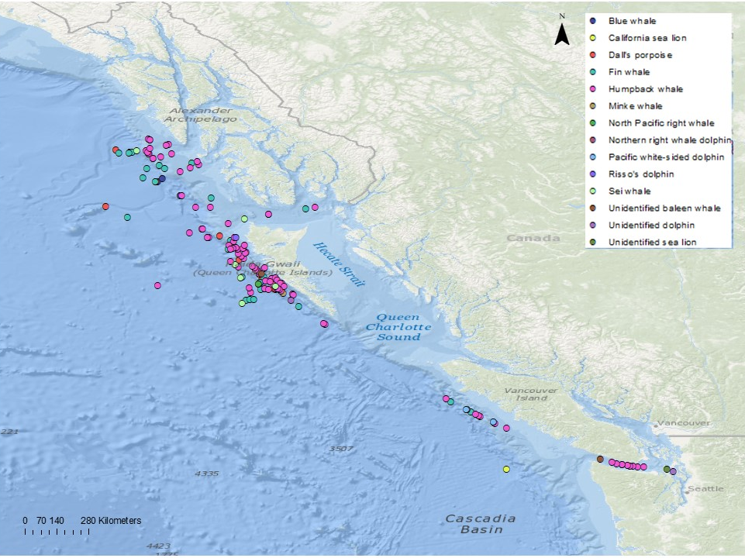
Figure 5: All protected species detections during the survey.

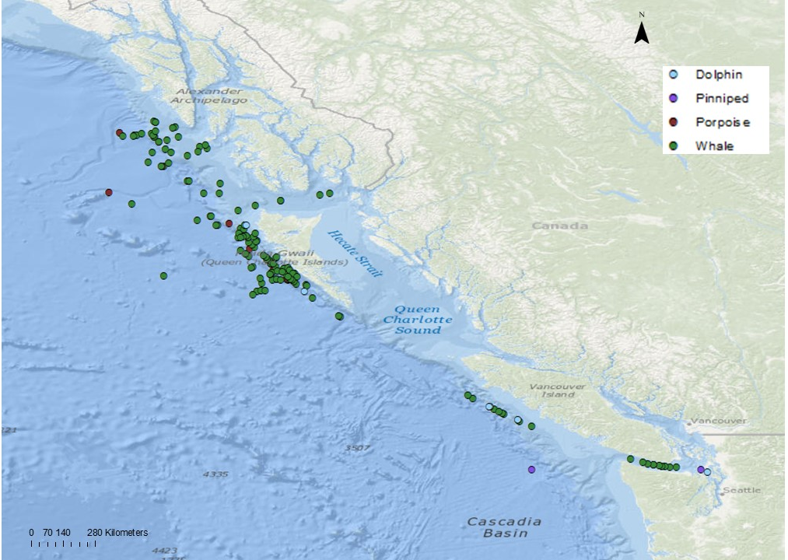
Figure 6: All protected species observed during the survey by species group.

Of the 160 visual detections, 106 detections (66%) occurred while the acoustic source was active, 54 detections (34%) occurred while the acoustic source was silent or not deployed.

For all of the dolphin species, only one detection of unidentified dolphins occurred while the source was active. The closest point of approach for that detection was 2,840 m. The closest point of approach while the source was silent or not deployed was the Risso’s dolphin at 408 m. The average closest point of approach for dolphin detections while the source was silent or not deployed was 567.8 m.

The porpoise detections were all of one species, Dall’s porpoise. Six of the detections were made while the source was active with an average closest point of approach of 775.5 m. There were four detections of Dall’s porpoise made while the source was silent or not deployed. Those detections had a closer point of approach average at 540.5 m compared to the average distance for detections while the source was active.

Of the 142 whale detections, 99 occurred while the source was active and 43 occurred while the source was silent or not deployed. The average closest point of approach for the active detections was 2202.13 m while the average closest point of approach when the source was silent or not deployed was 1710.4. The closest point of approach to an active source was the one detection a minke whale at 277 m. The closest point of approach while the source was silent or not deployed was a detection of sei whales at 271 m. All other species closest point of approach when the source was active or silent/not deployed were beyond 1300 m.

Both of the pinniped detections occurred while the source was silent or not deployed. The closest point of approach for both the California sea lion and unidentified sea lion detection was 700 m.

Table 21 lists the number of each species detected during each different source activity described above as well as the species average closest approach to the source during those times.

Table 21. Average closest approach of protected species to the acoustic source during the survey.
Species Detected | Acoustic Source Active |  | Acoustic Source Inactive
 | Number of detections | Mean closest observed approach to source (meters) | Number of detections | Mean closest observed approach to source (meters)
Northern right whale dolphin | 0 | - | 1 | 600
Pacific white-sided dolphin | 0 | - | 2 | 440
Risso’s dolphin | 0 | - | 1 | 408
Unidentified dolphin | 1 | 2840 | 1 | 951
All dolphin species | 1 | 2840 | 5 | 567.8
Dall’s porpoise | 6 | 775.5 | 4 | 540.5
All porpoise species | 6 | 775.5 | 4 | 540.5
Blue whale | 4 | 1888.75 | 0 | -
Fin whale | 17 | 2668.41 | 10 | 2722.6
Humpback whale | 70 | 2153.26 | 31 | 1437.1
Minke whale | 1 | 277 | 0 | -
North Pacific right whale | 1 | 4272 | 0 | -
Sei whale | 5 | 1398.4 | 1 | 271
Unidentified whale | 1 | 2824 | 1 | 1500
All whale species | 99 | 2202.13 | 43 | 1710.4
California sea lion | 0 | - | 1 | 700
Unidentified sea lion | 0 | - | 1 | 700
All pinniped species | 0 | - | 2 | 700

Other Wildlife

Observations of other wildlife during the survey included 18 species of birds, five species of fish, and two species of marine invertebrates. A complete list of birds and other marine wildlife observed and identified, in addition to the approximate number of individuals observed and the number of days on which they were observed, can be found in Appendix M. No impacts to any other wildlife species as a result of research activities were observed during the survey.

There were no detections of ESA (US) or SARA (Canada) protected bird species during the survey. There were sightings of tufted puffins and common murres during the survey, which are currently under consideration for ESA and SARA listing, respectively. There were also multiple sightings of the black-footed albatross during the survey, which are listed as a species of concern under SARA. This was the most common bird species sighted during the survey.

Acoustic detections
There were no acoustic detections of protected species during the survey.

mitigation action summary
There were 24 mitigation actions implemented during the survey due to protected species being observed approaching, entering, or within their designated exclusion zones. This included four delayed operations totaling three hours and 20 shutdowns totaling 12 hours 30 minutes (Table 22). Three of the delays to initiation of source was for whales totaling two hours and 24 minutes. There were no mitigation actions for sea turtles or sea birds during this survey.

Table 22. Number and duration of mitigation actions implemented during the survey.
Mitigation Action | Dolphins |  |  |  | Whales |  |  |  | Porpoises |  | Pinnipeds |  | All Species
 | No | Mitigation  Downtime |  | No. |  | Mitigation  Downtime |  | No. |  | Mitigation  Downtime | No. | Mitigation  Downtime | No. |  | Mitigation  Downtime
Delay of Initiation of Operation | 0 |  | - |  | 3 |  | 02:24 |  | 1 | 00:36 | 0 | - | 4 | 03:00
Shutdown of Operation | 0 |  | - |  | 17 |  | 10:40 |  | 3 | 01:50 | 0 | - | 20 | 12:30
Total Mitigation | 0 |  | - |  | 20 |  | 13:04 |  | 4 | 02:23 | 0 | - | 24 | 15:30

Protected Species known to have been exposed to 160 decibels or Greater of received sound levels
NMFS issued an IHA for the Queen Charlotte Fault survey on 09 July 2021 for 34 857 individual marine mammals. They also issued the BiOp on 7 July 2021 that authorized additional takes for three leatherback sea turtles, where behavioral harassment was expected to occur in the 175-decibel zone. Additionally, the FWS issued an IHA for the survey on 15 July 2021 for 27 takes of Northern sea otters. Under these regulatory documents, a total of 35 216 takes were authorized for 24 species/species groups.

Of the total approved takes, 311 marine mammals from eight species were authorized for Level A harassment takes (exposure to sound pressure levels where there is a potential for auditory injury based upon each species hearing range.) Over the course of the survey, two whales (one common minke whale and one fin whale) were observed inside the Level A harassment zone.

Furthermore, there were a total of 34 905 protected species from the 24 species authorized for Level B harassment takes (exposure to sound pressure levels equal to or greater than 160 dB re: 1 μPa (rms) where there is a potential for behavioral changes.) For the entirety of the survey, 135 individual protected species were observed within the Level B harassment zone from five species of whales and one species of porpoise.

During seismic operations, no takes of sea otters were observed. Operations did not appear to have any impact on sea otters or their availability for subsistence harvest.

The number of potential takes may be an underestimation and, therefore, may be a minimum estimate of the actual number of protected species potentially exposed to received sound levels within the predicted Level A and Level B harassment zones. It is possible that the estimated numbers of animals recorded were underestimates due to some individuals not being visually sighted or having moved away before they were observed, or some individuals not vocalizing and therefore not detected acoustically.

Table 23. Number of authorized and potential Level A and B Harassment Takes during the survey.
Species | IHA Authorized Level A Takes | Potential Level A Takes/PTS During the Program | IHA Authorized Level B Takes | Potential Level B Takes/TTS During the Program | Total IHA Authorized Takes | Total Potential Takes During the Program
North Pacific right whale | - | - | 2 | 2 | 2 | 2
Humpback whale | 14 | - | 403 | 67 | 417 | 67
Blue whale | 1 | - | 31 | 10 | 32 | 10
Fin whale | 44 | 1 | 873 | 24 | 917 | 25
Sei whale | 1 | - | 34 | 4 | 35 | 4
Minke whale | 2 | 1 | 57 | - | 59 | 1
Gray whale | 45 | - | 1450 | - | 1495 | -
Sperm Whale | - | - | 131 | - | 131 | -
Baird's beaked whale | - | - | 29 | - | 29 | -
Cuvier's beaked whale | - | - | 114 | - | 114 | -
Stejneger beaked whale | - | - | 120 | - | 120 | -
Pacific white-sided dolphin | - | - | 1374 | - | 1374 | -
Northern right-whale dolphin | - | - | 927 | - | 927 | -
Risso's dolphin | - | - | 22 | - | 22 | -
Killer whale | - | - | 290 | - | 290 | -
Dall's porpoise | 178 | - | 5661 | 28 | 5839 | 28
Harbor porpoise | 26 | - | 990 | - | 1016 | -
Northern fur seal | - | - | 5812 | - | 5812 | -
California sea lion | - | - | 1258 | - | 1258 | -
Steller sea lion | - | - | 2435 | - | 2435 | -
Northern elephant seal | - | - | 6850 | - | 6850 | -
Harbor seal | - | - | 6012 | - | 6012 | -
Northern sea otter | - | - | 27 | - | 27 | -
Leatherback sea turtle | - | - | 3 | - | 3 | -

implementation and effectiveness of the biological opinion’s its and iha
In order to minimize the potential impacts to marine mammals, sea turtles, and protected sea birds during the survey, LDEO and PSOs were prepared to implement mitigation measures whenever these protected species were detected approaching, entering, or within their designated exclusion zones as outlined in the IHAs, BiOp, LOC, EA, and LOA. There were 24 mitigation actions implemented during the survey for protected species, including four delays to initiation of source totaling three hours and 20 shutdowns totaling 12 hours and 30 minutes. The confirmation of the implementation of each term and condition of the project permit documents are described in this report.

In the event that an injured or dead protected species was discovered during the course of the survey, the incident was to be reported to the Office of Protected Resources (OPR), NMFS, and the NMFS Alaska Regional Stranding Coordinator as soon as possible. Sighting of an injured or dead northern sea otter was to be reported to the US Fish and Wildlife Service. While in the Canadian EEZ, causing death or about to cause the death of fish (including marine mammals) was to be reported to the DFO-Pacific Observe, Record and Report phone line. The report would include a detailed description of the incident (time, date, location, species identification, description of the animal, condition of the animal/carcass, observed behaviors if the animal was alive, and general circumstances under which the animal was discovered), including pictures when possible. There were no sightings of dead or injured protected species during the survey.

In order to prevent the occurrence of the vessel striking a marine mammal during transits, PSOs and vessel crew members maintained a vigilant watch for marine mammals, and the vessel was prepared to slow down, stop, or alter course as appropriate to avoid striking a protected species. The vessel speed had to be reduced to 10 knots or less when mother/calf pairs, pods, or large assemblages of cetaceans were observed near the vessel. The vessel had to maintain the minimum separation distances as described in
Table 2 in Section 3.1. If a marine mammal was sighted during transits, the vessel was to take action as necessary to avoid violating the relevant separation distances (e.g., attempt to remain parallel to the animal’s course, avoid excessive speed or abrupt changes in direction until the animal left the area). If marine mammals were sighted within the relevant separation distances, the vessel was required to reduce speed, shift the engines to neutral, and not engage the engines until the animals were clear of the area. These requirements did not apply in any case where compliance would create an imminent and serious threat to a person or vessel, or if the vessel was restricted in maneuverability due to towed equipment.

In the event of a ship strike of a marine mammal, the incident was to be reported to OPR, NMFS, and to the Alaska Regional Stranding Coordinator as soon as feasible. The report would include a detailed description of the incident (date, time, location, species identification, description of the animal(s) involved, vessel speed leading up to the incident, vessel’s course/heading and what operations were being conducted, status of all sound sources in use, description of avoidance measures taken if any, environmental conditions, description of the animals behavior preceding and following the strike, and estimated fate of the animal), including pictures when possible. There were no instances of the vessel striking a protected species during the survey.

In the event of a live stranding (or near-shore atypical milling) event of marine mammals within 50 kilometers of the survey operations, where the NMFS stranding network is engaged in herding or other interventions to return the animals to the water, LDEO would be advised of the need to implement shut-down procedures for all active acoustic sources operating within 50 kilometers of the stranding. The shut-down procedures would be implemented until all of the live animals had left the area, or until the marine mammals died or were euthanized. During the survey, LDEO was not contacted by NMFS to shutdown activities due to any live marine mammal strandings near the survey area.

Passive acoustic monitoring was conducted throughout the survey and the majority of acoustic monitoring was undertaken while the source was active. High vessel speeds (greater than six knots) can result in high levels of background noise, which made it impractical to conduct acoustic monitoring while the vessel was in transit. This prevented baseline acoustic data from being collected both within and outside of the survey area while visual monitoring was ongoing for baseline data collection purposes. There were no acoustic detections of protected species during the survey.

PSOs likely did not detect all animals present; however, it is highly unlikely that the actual number of animals present during survey operations reached anywhere near the fully authorized levels for all species. The combination of conservative predicted mitigation zones combined with conservative take estimation by NMFS (i.e., the precautionary approach), appears for most species to have resulted in an overestimation of take and of overall impact on marine species from the activity. The monitoring and mitigation measures required by the IHA and ITS appear to have been an effective means to protect the marine species encountered during survey operations.

Literature Cited

NOAA, 2020. Endangered Species Act Section 7 Consultation Biological Opinion for a marine seismic survey by Lamont-Doherty Earth Observatory in the North Pacific Ocean and NFMS IHA issuance.

Crone, T.J., M. Tolstoy, and H. Carton. 2014. Estimating shallow water sound power levels and mitigation radii for the R/V Marcus G. Langseth using an 8 km long MCS streamer. Geochem., Geophys., Geosyst. 15(10):3793-3807.

Crone, T.J., M. Tolstoy, and H. Carton. 2017. Utilizing the R/V Marcus G. Langseth’s streamer to measure the acoustic radiation of its seismic source in the shallow waters of New Jersey’s continental shelf. PloS ONE 12(8): e0183096. http://doi.org/10.1371/journal.pone.0183

